|  |
| --- |
| Computer technician with an understanding of computer hardware, Windows operating systems, software troubleshooting, networking, and mobile devices. 5+ years of general office experience providing excellent customer service, staff support, and communication skills. Proficient in invoice processing, data collection, and data entry. |
| Certifications & Education |
|  |
| * **Comptia A+ Certification**   03/16/19   * **Georgia State University** Atlanta, GA |
| *Senior,*Computer Science 2014-present |
| **Experience** |
| Atlanta Public Schools - Heritage Academy Elementary Atlanta, Ga  *Paraprofessional – Special Education*  November 2016 – May 2019  - Provide instruction to students with disabilities in accordance to the supervising teacher’s lesson plans.  - Collect data for all objectives being taught for each student.  - Implement Behavior Intervention Plus for students with disabilities  - Perform other duties as assigned by classroom teacher or administrator  Morehouse School Of Medicine Atlanta, Ga  *Student Assistant, Office of the Controller* 2010-May 2016 |
| * **Accounts Payable**   -Process invoices daily using Banner  -Process all incoming mail and online inquiries  -Provide customer service for vendors seeking payment of invoices in a positive manner via the AP Help Desk.  -Verify the accuracy of vendor information, purchase orders, payment terms, and account codes during processing using Banner  -Utilize Microsoft Excel to create spreadsheets and reports by logging all invoices to measure efficiency.  -Assist the Accounts Payable team with weekly check runs.   * **Purchasing/Procurement**   -Process purchase orders  -Evaluate, approve, and set up vendors  -Review requisitions daily   * **Grants & Contracts**   -Produce relevant reports using Microsoft Excel for the Grants & Contracts staff  -Organize and maintain Grants & Contracts proposal folders  -Work collaboratively with the Grants & Contracts team by providing backup support by developing and maintaining record keeping and filing systems |
|  |
|  |

Software

* **Microsoft Office**
* **Adobe Creative Cloud**



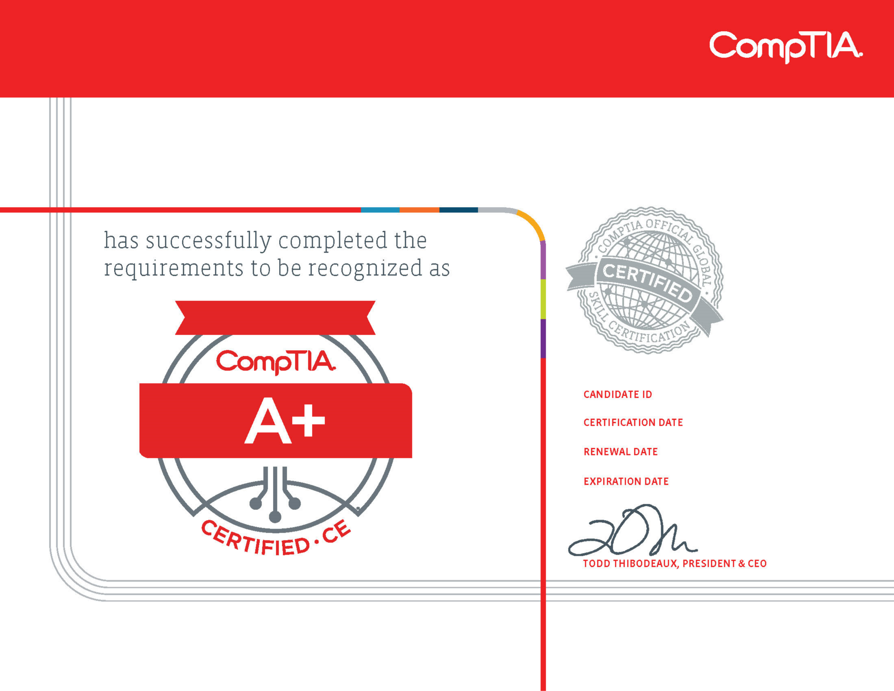

Vincent Todd Salter Jr

COMP001021346944

March 16, 2019

Code: 0TK1ZTQ3RHBEQVWW

Verify at: http://verify.CompTIA.org

**VERSION 2019**

March 16, 2019

March 16, 2022